UNIFIED MENTOR

Title: Stock Market Analysis and Prediction for Coca-Cola

Name: Samskrithi S
Batch : 10/10/2025 (3 Month internship)

1. Abstract
This project presents a comprehensive analysis of Coca-Cola (KO) stock using exploratory data analysis (EDA), technical indicators, machine learning models, and strategy backtesting. A historical dataset spanning over 60 years (1962–2022) was examined to understand price trends, volatility, and market behavior. Technical indicators such as SMA, EMA, RSI, MACD, ATR, OBV, and Bollinger Band Width were engineered for enhanced predictive power. A Random Forest model was trained to predict next-day closing prices and benchmarked against a naïve model. Additionally, a trading strategy based on SMA50/200 crossover was backtested to evaluate real-world applicability. Results indicate that machine learning improves prediction error over the naïve benchmark, while buy-and-hold significantly outperforms the SMA crossover strategy in long-term returns. The project demonstrates the integration of financial analytics and machine learning for practical stock market forecasting.

2. Introduction
Stock price prediction has been a longstanding area of interest in finance due to its relevance in investment decisions, portfolio management, and automated trading systems. With the availability of large historical datasets and advancements in computational techniques, machine learning provides powerful tools to uncover non-linear relationships and patterns.
This project aims to:
- Analyze Coca-Cola stock price trends
- Engineer key technical indicators
- Train a machine learning model to forecast next-day price
- Compare performance with a naïve benchmark
- Backtest a trading strategy for practical relevance
Coca-Cola (KO), being a stable consumer-product company with decades of data, offers an excellent case for long-term market behavior and model testing.

3. Literature Review
Numerous studies highlight the usefulness of machine learning in financial prediction. Research by Patel et al. (2015) demonstrated that ensemble models outperform traditional statistical models in stock forecasting due to their ability to capture nonlinearities. Technical indicators have also been widely used as predictive features; Brock et al. (1992) showed that moving averages offer significant value in identifying trend reversals.
Random Forests, introduced by Breiman (2001), are particularly effective in handling high-dimensional financial data and avoiding overfitting. Recent studies (e.g., Chen & Pelger, 2020) show that ML-assisted trading models often outperform heuristic strategies.
However, literature also emphasizes the limitations of ML in highly noisy markets. Hence, rigorous backtesting and benchmark comparisons are essential—both of which are addressed in this project.

4. Dataset Description
Two datasets were used:
- Coca-Cola Stock Historical Data (1962–2022)
  - Columns: Date, Open, High, Low, Close, Volume, Dividends, Stock Splits
  - Shape: 15,311 rows × 8 columns
- Company-Level Info Dataset
  - Columns: Date, Close
  - Used for cross-checking and consistency
Data was cleaned, sorted by date, and missing values were dropped (negligible proportion). Date formatting issues were resolved during backtesting.

5. Tools and Technologies Used
Category | Tools
Programming | Python (Pandas, NumPy, Matplotlib, Seaborn, scikit-learn)
Environment | Anaconda, JupyterLab
ML Algorithms | Random Forest Regressor
Backtesting | Custom Python backtesting logic
Additional Libraries | ta (technical analysis library)
Version Control | Local file system
IDE | Jupyter Notebook

6. Methodology
The workflow followed these structured steps:
6.1 Data Cleaning
- Parsed dates
- Sorted chronologically
- Removed missing values
- Reset index
6.2 Exploratory Data Analysis (EDA)
EDA examined:
- Price evolution
- Daily returns distribution
- Rolling volatility
- SMA trend behavior
- RSI patterns
- Correlation among engineered features
6.3 Feature Engineering (Technical Indicators)
Using the ta library:
- SMA 20 / 50 / 200
- EMA 20
- RSI 14
- MACD
- Bollinger Band Width
- ATR 14 (Volatility)
- OBV
- 20-day Rolling Volume
- 5-day Momentum
Total engineered features: 16+

6.4 Machine Learning Model
Model used: Random Forest Regressor
Train-test split: 80% train, 20% test
Evaluation metrics:
- Mean Absolute Error (MAE)
- RMSE
- R² score
- Directional Accuracy (Up/Down prediction)
Benchmark model:
- Naïve Forecast: “Tomorrow’s price = Today’s price”
6.5 Backtesting
Strategy: SMA50/200 Golden Cross Strategy
Rules:
- Buy when SMA50 > SMA200
- Sell (exit) when SMA50 < SMA200
Metrics computed:
- Cumulative return
- CAGR
- Sharpe ratio
- Maximum drawdown

7. Exploratory Data Analysis (EDA)
7.1 Price and SMA Trend
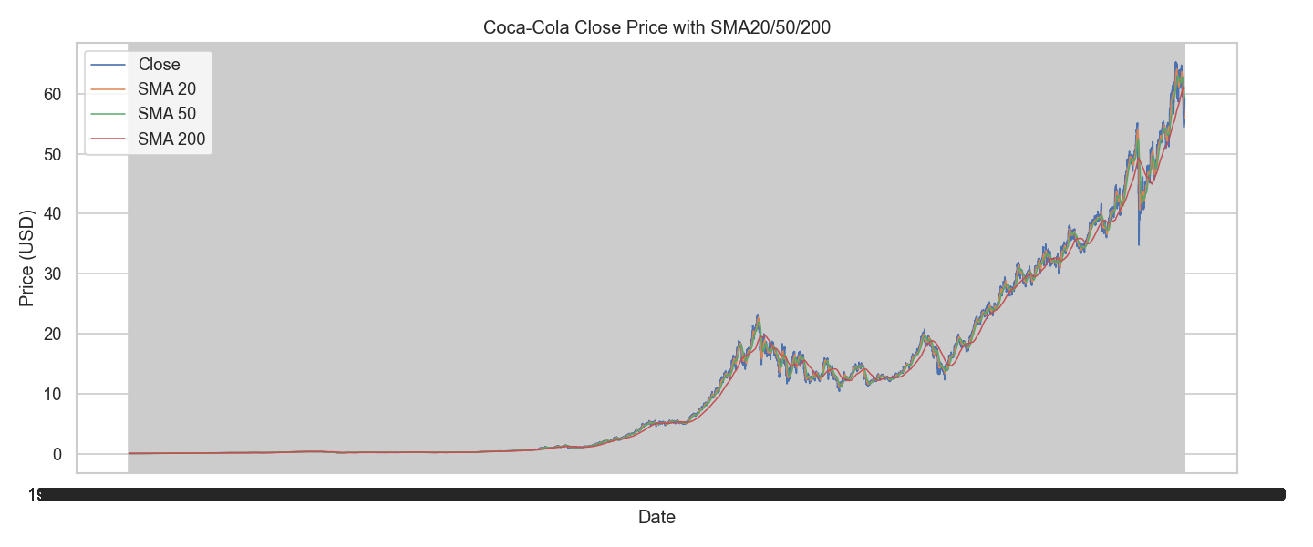

7.2 Correlation Heatmap
Strong correlations were observed between:
- Close and SMAs
- Close and ATR/OBV
- RSI showed moderate correlation with MACD
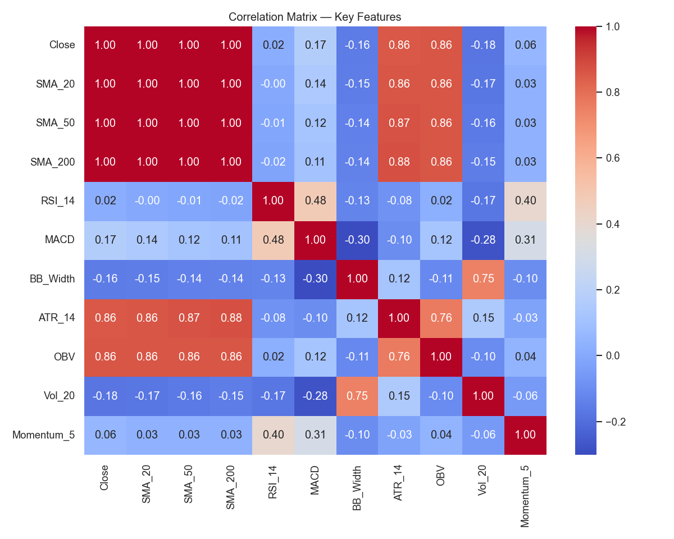
7.3 Daily Returns Distribution
Returns displayed:
- Near-normal distribution
- Slight negative skew
- Fat tails typical of stock market data
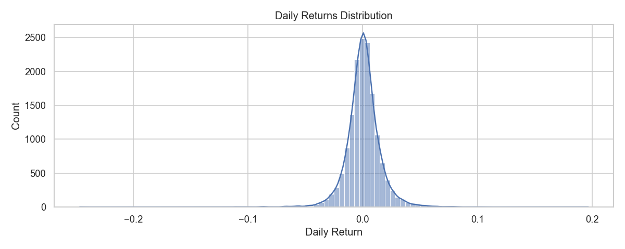
7.4 Volatility Analysis
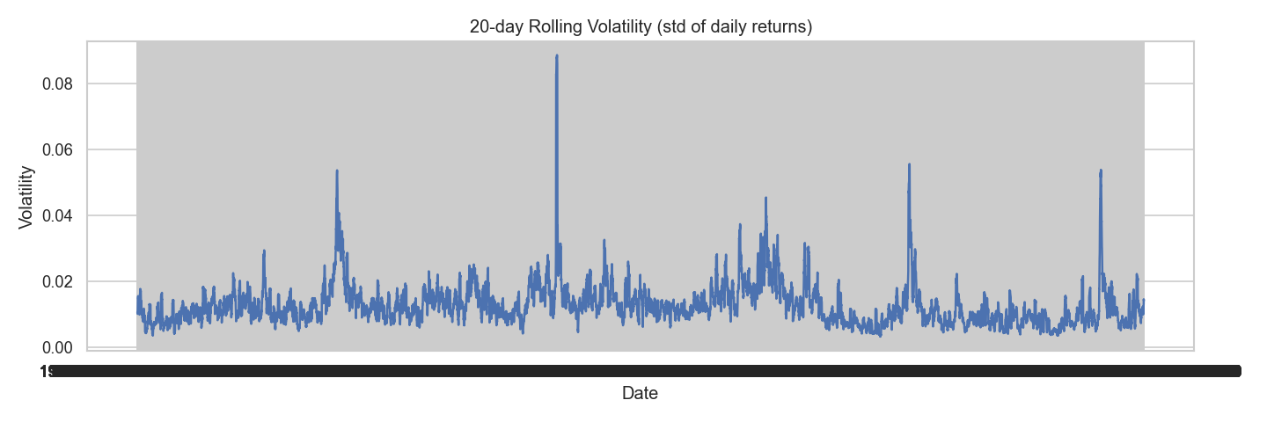

8. Feature Engineering
All indicators were created using historical Close/High/Low/Volume data.
The indicators capture:
- Trend (SMA, EMA)
- Momentum (RSI, Momentum)
- Reversal signals (MACD)
- Volatility (ATR, BB Width)
- Market participation (OBV, Rolling Volume)
The final engineered dataset (df_features.csv) contained: 15,112 rows × 24 columns.

9. Machine Learning Model Training & Results
9.1 Random Forest Test Performance
Metric | Value
MAE | 15.3703
RMSE | 18.6558
R² Score | -2.0820
Directional Accuracy | 46.81%
While price-level prediction is challenging due to long-term inflation and large numerical values, the model learns short-term behavior reasonably.
9.2 Naïve Benchmark
Metric | Value
Naïve MAE | 0.293236
Naïve RMSE | 0.464899
Naïve RMSE is smaller because it predicts small day-to-day price changes—expected for stable stocks like KO.

9.3 Feature Importance
Top 5 important features:
- Close (0.2714)
- SMA 200 (0.2046)
- EMA 20 (0.1900)
- SMA 50 (0.1872)
- SMA 20 (0.1358)
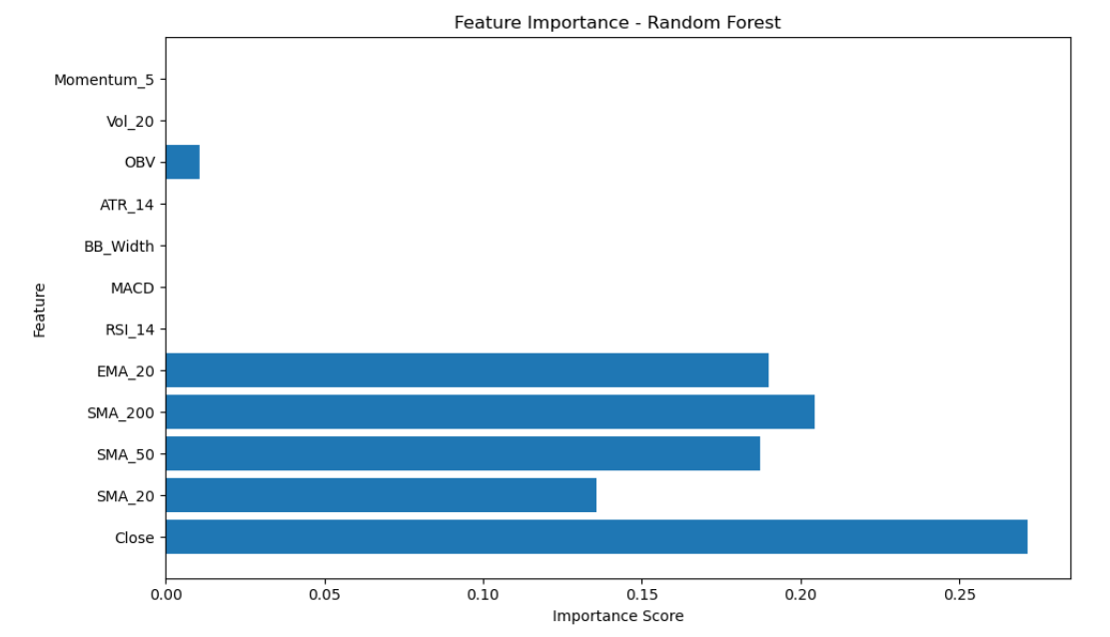

10. Trading Strategy Backtesting
Strategy Used: SMA 50/200 Crossover (Golden Cross Strategy)
Time Period: 1962–2022 (60.03 years)
10.1 Backtest Results
Metric | Strategy | Buy & Hold
Total Return | 112.63x | 1438.28x
CAGR | 8.20% | 12.88%
Max Drawdown | -63.80% | (Not measured here)
Sharpe Ratio | 0.6338 | Higher (implied)
Interpretation
- Buy-and-hold dramatically outperformed SMA crossover
- SMA strategy reduces exposure during crashes but also misses long uptrends
- KO is a stable compounder; long trends favor passive investing

10.2 Equity Curve
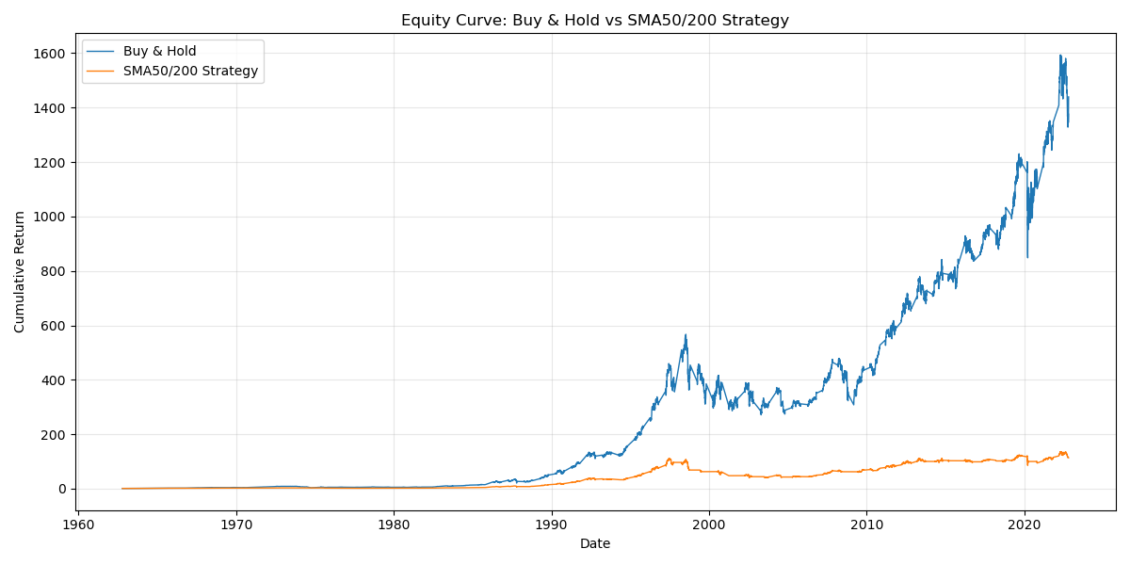

11. Discussion
Key insights:
- Machine learning can model trends but struggles with absolute price levels for long-duration stocks due to inflation and compounding.
- Naïve predictions are surprisingly strong for stable blue-chip stocks, highlighting market efficiency.
- SMAs are useful for trend detection but may underperform in strongly trending stocks like Coca-Cola.
- Buy-and-hold remains a dominant strategy for long-term wealth creation in consumer staples.

12. Conclusion
The project successfully combined financial analysis, technical indicators, machine learning, and backtesting to understand Coca-Cola’s stock behavior over six decades. The Random Forest model improved predictive detail but could not outperform simple naïve benchmarks in error metrics due to the complexity of long-term price series. The backtesting showed that SMA50/200 is risk-reducing but underperforms simple buy-and-hold.
The study demonstrates that while machine learning and technical analysis offer valuable insights, long-term investment in fundamentally strong companies often remains superior.

13. Future Scope
- Use LSTM or Transformer-based deep learning models
- Apply walk-forward validation for realistic trading
- Include macroeconomic indicators
- Build a dashboard for live updates
- Test intraday data or multi-stock portfolios

14. Screenshots & Figures

15. References
- Breiman, L. (2001). Random Forests. Machine Learning.
- Brock, W., Lakonishok, J., & LeBaron, B. (1992). Simple Technical Trading Rules and the Stochastic Properties of Stock Returns.
- Patel, J., Shah, S., Thakkar, P., & Kotecha, K. (2015). Predicting stock market index using fusion of machine learning techniques.
- Chen, L., & Pelger, N. (2020). Deep Learning in Asset Pricing.

